First Sunday of Advent
November 30, 2025—10am

Holy Communion Lutheran Church
6220 Portsmouth Blvd, Portsmouth, VA 23701
757-488-2604
www.HCPort.com

Mission: To make Christ known in our actions and our faith
Vision: We are a community living out the gospel of Jesus Christ by service to the Portsmouth Community and by following Jesus.

Page numbers (p.) are in front half of the hymnal.
Hymn numbers (#) are in back half of the hymnal.
Everyone is invited to join in bolded responses.
‘+’ Please stand as you are able.

+ Gathering +
The Holy Spirit calls us together as the people of God.

Prelude “Wake up, the voice calls us”
from BWV 645 by J.S. Bach

+ Lighting of the Advent Wreath ELW #253

+ Confession and Forgiveness
All may make the sign of the cross, the sign that is marked at baptism, as the presiding minister begins.
Blessed be the holy Trinity, ☩ one God, whose home is heaven and earth, whose salvation is sure. Amen.

Let us confess our sin in the presence of God and of one another.
Silence is kept for reflection.
Long-expected God, we confess that we look to ourselves for the peace and security only you can provide. We reach for swords and spears, reluctant to release our grip on the ways of war. We become impatient while waiting and weary of keeping awake.
Free us from self-reliance, and teach us to live in harmony with our neighbors. Increase our trust in God’s timing, and awaken us to your advent among us, that we may abound in the hope you have promised. Amen.

God judges us not as we deserve, but according to God’s own righteousness. ☩ You are freed and forgiven, saved by grace, and ready to welcome the Savior. Amen.

+ Gathering Song ELW #260 “The King Shall Come”

+ Greeting ELW p.203
The grace of our Lord Jesus Christ, the love of God, and the communion of the Holy Spirit be with you all.
And also with you.

+ Kyrie ELW p. 203
+ Prayer of the Day ELW p.18

+Word+
God speaks to us in scripture reading, preaching, and song.

First Reading Isaiah 2:1-5

A reading from Isaiah.

¹ The word that Isaiah son of Amoz saw concerning Judah and Jerusalem. ² In days to come the mountain of the Lord’s house shall be established as the highest of the mountains and shall be raised above the hills; all the nations shall stream to it. ³ Many peoples shall come and say, “Come, let us go up to the mountain of the Lord, to the house of the God of Jacob, that he may teach us his ways and that we may walk in his paths.” For out of Zion shall go forth instruction and the word of the Lord from Jerusalem. ⁴ He shall judge between the nations and shall arbitrate for many peoples; they shall beat their swords into plowshares and their spears into pruning hooks; nation shall not lift up sword against nation; neither shall they learn war any more. ⁵ O house of Jacob, come, let us walk in the light of the Lord!

The word of the Lord. Thanks be to God.

Psalm 122 ELW #122
¹ I was glad when they | said to me,
“Let us go to the house | of the Lord.”
² Now our | feet are standing
within your gates, | O Jerusalem.
³ Jerusalem is built | as a city
that is at unity | with itself;
⁴ to which the tribes go up, the tribes | of the Lord,
the assembly of Israel, to praise the name | of the Lord.
⁵ For there are the | thrones of judgment,
the thrones of the | house of David.
⁶ Pray for the peace | of Jerusalem:
“May they pros- | per who love you.
⁷ Peace be with- | in your walls
and quietness with- | in your towers.
⁸ For the sake of my kindred | and companions,
I pray for | your prosperity.
⁹ Because of the house of the | Lord our God,
I will seek to | do you good.”

Second Reading Romans 13:11-14

A reading from Romans.

¹¹ Besides this, you know what time it is, how it is already the moment for you to wake from sleep. For salvation is nearer to us now than when we became believers; ¹² the night is far gone; the day is near. Let us then throw off the works of darkness and put on the armor of light; ¹³ let us walk decently as in the day, not in reveling and drunkenness, not in illicit sex and licentiousness, not in quarreling and jealousy. ¹⁴ Instead, put on the Lord Jesus Christ, and make no provision for the flesh, to gratify its desires.

The word of the Lord. Thanks be to God.

+ Gospel Acclamation ELW p.205

+ Gospel Reading Matthew 24:36-44

The holy gospel according to Matthew.
Glory to you, O Lord.

[Jesus said to the disciples,] ³⁶ “About that day and hour no one knows, neither the angels of heaven, nor the Son, but only the Father. ³⁷ For as the days of Noah were, so will be the coming of the Son of Man. ³⁸ For as in the days before the flood they were eating and drinking, marrying and giving in marriage, until the day Noah entered the ark, ³⁹ and they knew nothing until the flood came and swept them all away, so, too, will be the coming of the Son of Man. ⁴⁰ Then two will be in the field; one will be taken, and one will be left. ⁴¹ Two women will be grinding meal together; one will be taken, and one will be left. ⁴² Keep awake, therefore, for you do not know on what day your Lord is coming. ⁴³ But understand this: if the owner of the house had known in what part of the night the thief was coming, he would have stayed awake and would not have let his house be broken into. ⁴⁴ Therefore you also must be ready, for the Son of Man is coming at an hour you do not expect.”

The gospel of the Lord. Praise to you, O Christ.

Young at Heart Message & Sermon
Seminarian Kate Hoffstaeter

+ Song of the Day ACS #949

Nicene Creed ELW p.104
We believe in one God, the Father, the Almighty,
maker of heaven and earth,
of all that is, seen and unseen.
We believe in one Lord, Jesus Christ, the only Son of God,
eternally begotten of the Father,
God from God, Light from Light,
true God from true God,
begotten, not made, of one Being with the Father;
through him all things were made.
For us and for our salvation
he came down from heaven,
was incarnate of the Holy Spirit and the virgin Mary
and became truly human.
For our sake he was crucified under Pontius Pilate;
he suffered death and was buried.
On the third day he rose again
in accordance with the scriptures;
he ascended into heaven
and is seated at the right hand of the Father.
He will come again in glory to judge the living and the dead, and his kingdom will have no end.
We believe in the Holy Spirit, the Lord, the giver of life,
who proceeds from the Father and the Son,
who with the Father and the Son is worshiped and glorified, who has spoken through the prophets.
We believe in one holy catholic and apostolic church. We acknowledge one baptism for the forgiveness of sins.
We look for the resurrection of the dead, and the life of the world to come. Amen.
+ Prayers of Intercession ELW #262

+ Peace

+Thanksgiving+

Offering

Thank you for supporting the mission of Holy Communion Lutheran Church as you are able! Electronic donations can be made at https://give.tithe.ly/?formId=135fdb3c-6865-11ee-90fc-1260ab546d11

+ Offering Prayer
Nourishing God, you are water in the wilderness and streams in the desert. Through this meal, satisfy our parched places, that we may rejoice and be for the world signs of your kingdom come. Amen.

+ Canticle of Thanksgiving ELW p.219-20

continued on next page

+ Thanksgiving for the Word ELW p.220
O God of justice and love, we give thanks to you that you illumine our way through life with the words of your Son. Give us the light we need, awaken us to the needs of others, and at the end bring all the world to your feast; through Jesus Christ, our Savior and Lord, to whom, with you and the Holy Spirit, be honor and glory forever. Amen.

+ Lord's Prayer ELW p. 221
Our Father, who art in heaven,
hallowed be thy name,
thy kingdom come,
thy will be done, on earth as it is in heaven.
Give us this day our daily bread;
and forgive us our trespasses,
as we forgive those who trespass against us;
and lead us not into temptation,
but deliver us from evil.
For thine is the kingdom,
and the power, and the glory,
forever and ever. Amen.
+ Sending +
God blesses us and sends us in mission to the world.

+ Blessing
May God who comes among us,
Father, ☩ Son, and Holy Spirit,
grant you patience in waiting, peace in the darkness,
and good news to share today and always. Amen.

Announcements

+ Sending Song ELW #439 (see next pages)

+ Dismissal
Go in peace. Keep awake. Thanks be to God.

Postlude

Reprinted, podcasted, and streamed with permission under Augsburg Fortress Liturgies Annual License #SAS012006, One License # A-726145, CCLI License #1881789, and CCLI Streaming License #20660555. All rights reserved.
New Revised Standard Version Updated Edition.
Copyright © 2021 National Council of Churches of Christ in the United States of America. Used by permission. All rights reserved worldwide.

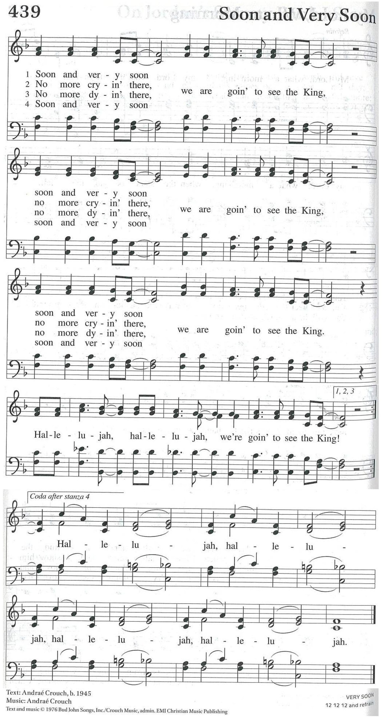
continued on next page

